**Homepage**

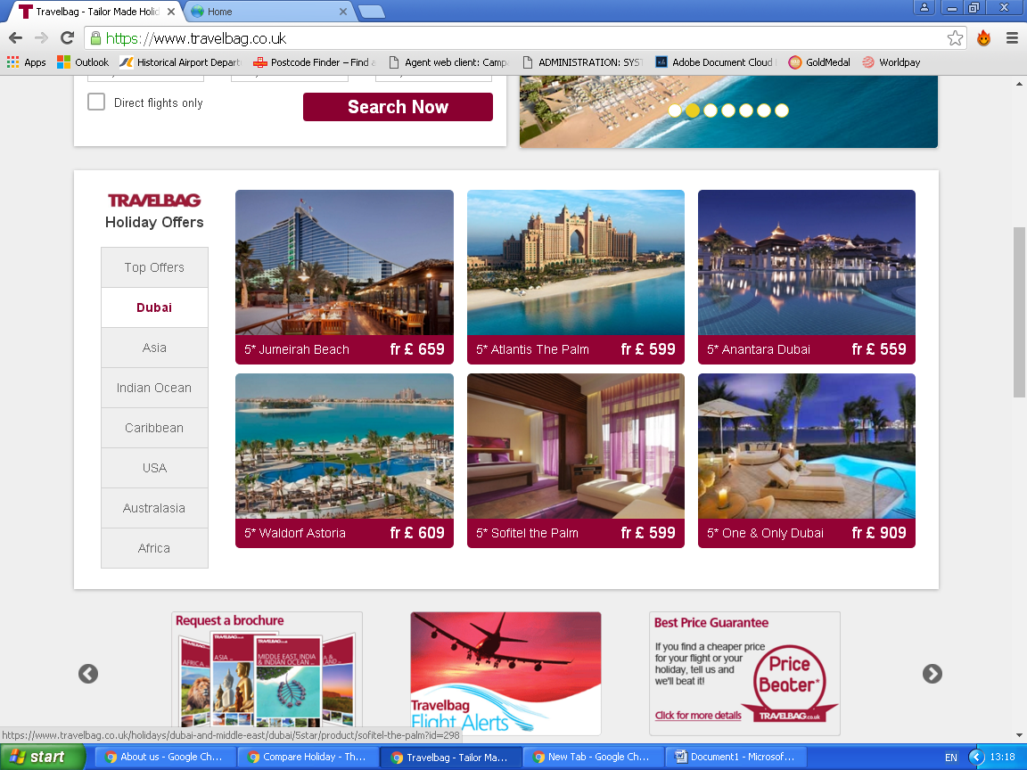I’d like the below layout – with the following destinations stating the offers available with starting prices, here’s the webpage to give you a better idea

<https://www.travelbag.co.uk>

**Bottom of homepage**

Please add these icons as it shows clients that I’m officially registered and have the required certificates in place.

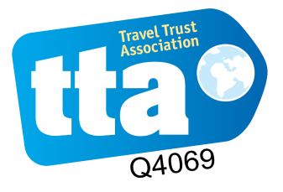

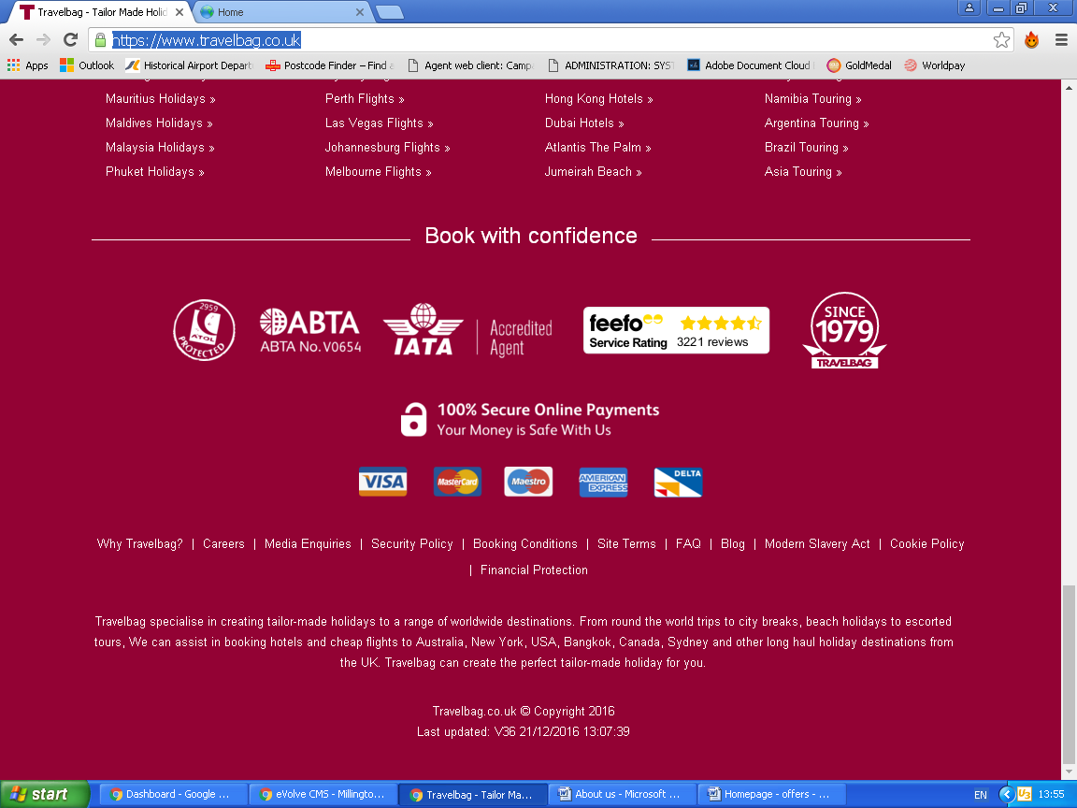Replace Icon with the ones above

Keep text